*xy*>0

* **Quantity A**

*x*2*y*4

• • **Quantity B**

*x*3*y*6

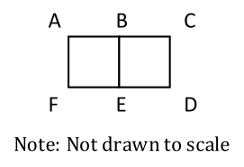

In the figure shown above, line segment BC has length 16 cm, rectangle FABE is a square, and the area of rectangular region FACD is 612 cm2.

* **Quantity A**

Area of FABE

* **Quantity B**

Area of EBCD

Working independently, Machine A can complete a work in 3.5 hours, while Machine B can complete the same work in *x*

hours. Working simultaneously, they together complete the same work in 1.5 hours.

* **Quantity A**

3

• • **Quantity B**

*x*

A driver completed the first 20 miles of a 40-mile trip at an average speed of 50 miles per hour and the second 20 miles at an average speed of *x*

miles per hour. The average speed for the entire 40-mile trip was 60 miles per hour. (Assume that the driver did not make any stops during the 40-mile trip.)

* **Quantity A**
* *x*−60

• • **Quantity B**

10

A positive integer *x* is a perfect number if the sum of all the factors of *x*, including 1 and *x*, is equal to 2*x*

.

* **Quantity A**

The sum of the reciprocals of all the factors of the perfect number 28

* **Quantity B**

2

The sequence *a*1,*a*2,*a*3,…*an*,… is such that *a*1=−2,*a*2=−5,*a*3=4,*a*4=3,and*an*=*an*−4for*n*>4

.

* **Quantity A**

The sum of the first 64 terms of the sequence

* **Quantity B**

The sum of the first 98 terms of the sequence

3,*a*,1,9,*b*,3

The arithmetic mean of the list of numbers above is 4

and *a* and *b*

are integers.

* **Quantity A**

Median of the list

* **Quantity B**

Mean of the list

*x* is chosen at random from the set {1,2,3,4} and *y* is chosen at random from the set {5,7,9}

.

* **Quantity A**

The probability that *xy*

• will be even

• **Quantity B**

The probability that (*x*+*y*)

will be even

4<7−*x*3

* **Quantity A**

Maximum value of −(5−*x*)

• • **Quantity B**

Maximum value of 2*x*

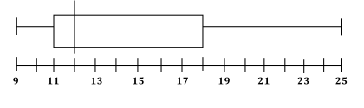

The box-and-whisker plot above shows weights for 60 kids in a playgroup. How many kids weight between 18 kilograms and 23 kilograms, inclusive, if the 23 kilograms represents the 90th percentile value on the plot above?

If the roots of the equation *x*2−16*x*−612=0 are *a* and *b*, what is the value of *a*+*b*?

If√ *x*+6−√+*x*+1 =5, what is the value of *x*2?

David bought greater than 10 paperback books that cost $8 each and greater than 8 hardcover books that cost $20 each. If the total cost of all the books that he bought was between $240 and $300, exclusive, how many total number of books could he buy?

Indicate all such answers 17, 18, 19 ,20 , 21, 22, 23

If *x* and *y* are non-negative integers such that 2*x*+3*y*=8 and *z*=*x*2+*y*2, what is the maximum value of *z*?

If ABC is a straight line as shown in the figure below, and the angles *x* & *y* are integer multiples of 20, what is the value of *x*

?

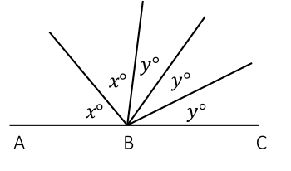

B 20, 40, 60, 80, 100

If *x* is a non-negative integer such that 7*x*√+24*x*√=25*x*√, what is the value of

If −1<*h*<0, which of the following has the greatest value?

If the average (arithmetic mean) of five distinct positive integers is 10, what is the difference between the largest possible value of the greatest integer and the least possible value of the greatest of the five integers?

If two sets, Set A:{−10,−3,*y*2,9,10,11}, and Set B:{0,2,−2*y*,12,13,15} have their elements arranged in ascending order, and have equal median values, what is the value of *y*?



The box-and-whisker plot above shows weights for 60 kids in a playgroup. How many kids weight between 18 kilograms and 23 kilograms, inclusive, if the 23 kilograms represents the 90th percentile value on the plot above?

If two interior angles of a quadrilateral ABCD are right angles and the degree measure of ∠ABC is twice the degree measure of ∠BCD, what could be the measure of the largest interior angle of quadrilateral ABCD?

Indicate all such angles.

90, 105, 120, 135, 150, 180

If the length and the breadth of a rectangle each is a prime number less than 11, and the perimeter of the rectangle is less than 24 unit, which of the following could be the possible value of the area?

Indicate all such areas. 4, 6, 9, 15, 14, 20, 25, 35

f *ab*>*cd*, and none of *a*, *b*, *c*, and *d*

is equal to 0, which of the following must be true?

Indicate all such answers.

f *ab*>*cd*, and none of *a*, *b*, *c*, and *d*

is equal to 0, which of the following must be true?

Indicate all such answers.

−*ab*<*cd*

∣∣*ab*∣∣>∣∣*cd*∣∣

falseC*ba*<*dc*

trueD−*ab*<−*cd*

In a certain batch of guests in a museum, there are 50 guests; each guest buys either a $40 ticket or a $60 ticket, with at least one guest of each ticket type. The average (arithmetic mean) value of ticket-receipts from the batch is more than $50. If the average value of ticket-receipts is to be reduced to less than $50 by including few new guests with $40 tickets, what could definitely NOT be the number of new guests with $40 tickets that could be included?

Indicate all such number 1, 2, 3, 4

What could be the values of integers from 180 to 300, inclusive, that leave the remainder 2 when divided by 15 and by 9?

Indicate all such numbers. 181, 191, 197, 227, 242, 272 , 281

If |*x*|=|*y*|, which of the following must be true?

*x*<*y*

falseB*y*>*x*

falseC*x*=*y*

falseD*x*3=*y*3

trueE*x*4=*y*4

Which of the following statements individually provide enough information to determine the number of students in a group?

Indicate all such statements

trueAThe number of ways 3 students can be selected from the group to form a team is 35.

trueBThe number of ways 3 students from the group can be seated in a row is 210.

* CThe number of ways all the students from the group can be selected to form a team is 1.

trueDThe number of ways 3 students can be selected from the group to form a team equals the number of ways 4 students can be selected from the group to form a team.

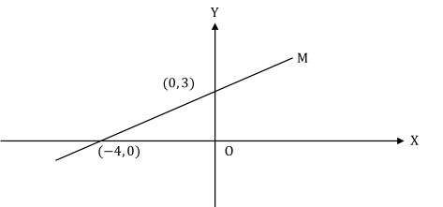

The graph of which of the following equations is a straight line that is parallel to line M in the figure above and intersects the negative direction of Y-axis?

Indicate all such equations.

falseA4*y*+3*x*=0

trueB4*y*−3*x*=−2

falseC4*y*−3*x*=4

falseD4*y*+3*x*=−4

trueE4*y*−3*x*=−1

falseF4*y*−3*x*=0

In a test, five students of a class scored 39, 37, 40, 34, and 36, respectively. If the sixth student scored *n* marks, for which of the following values of *n*

does the average (arithmetic mean) score per student for the six students equal the median score?

Indicate all such values.

trueA33

falseB37

trueC42